Instructions for the Use of Epileptic EEG Analysis

Author: Kong Xianghan

（Demodulate 50Hz interference by default）

1. Click the ‘Epileptic EEG Analysis’ bottom and choose the EEG file.

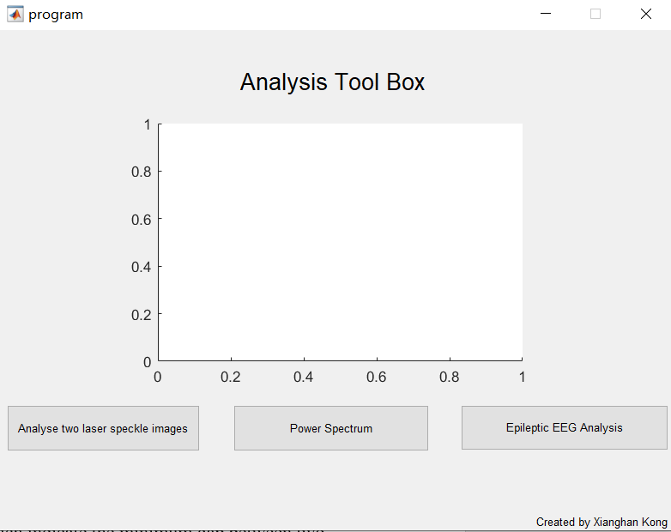

1. Set the start and end point of baseline data. And get the 50Hz signal demodulation and wavelet threshold data.

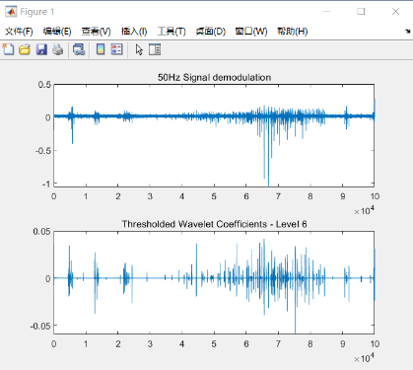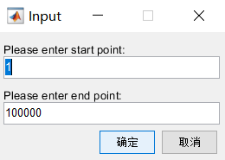

1. Set the type of signal. 0 for interictal spike, 1 for fast ripple.

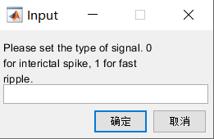

1. Click the start and end point of baseline data with the cursor in the chart. And get the analysis of the baseline data.

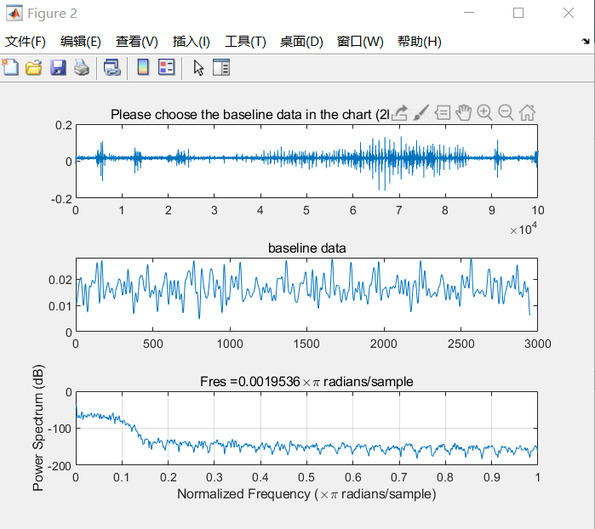 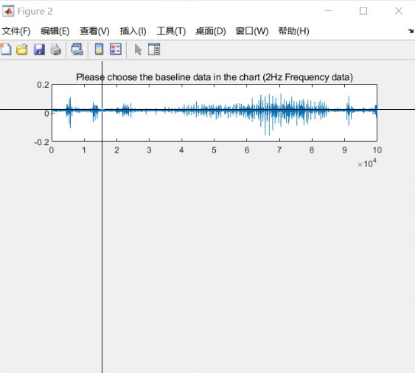

1. Set the coefficient of baseline and the spike distance, for example: 3\*β\*baseline, defaulted β is 1. If 100 spike distance was set, there are at least 100 points between two spiking.

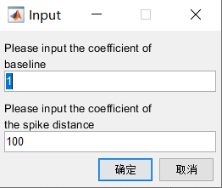

1. Click the start and end point of the experiment data with the cursor in the chart.

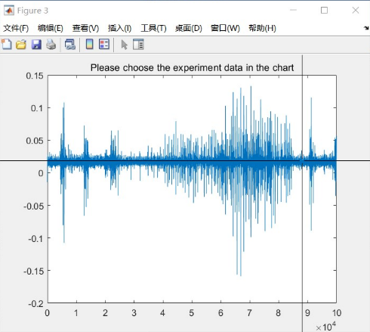

1. The total number of spikes is displayed on the screen, and the recording spikes are marked on the chart. Please check these spikes in both time and wavelet domain.

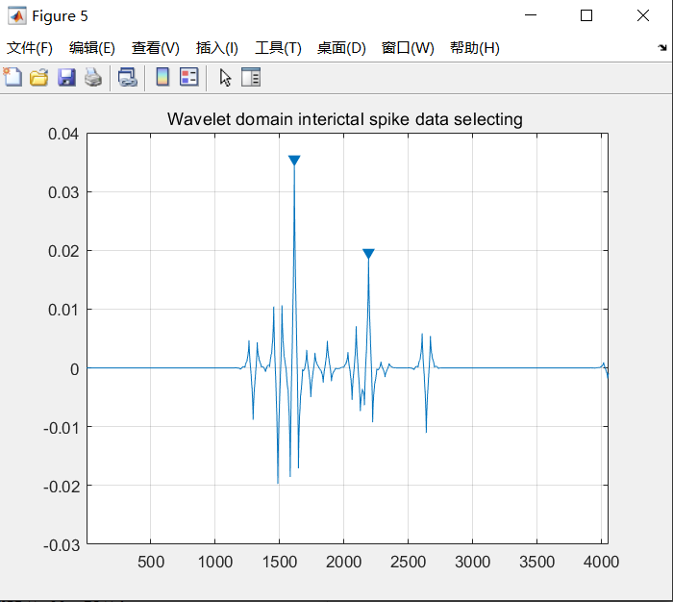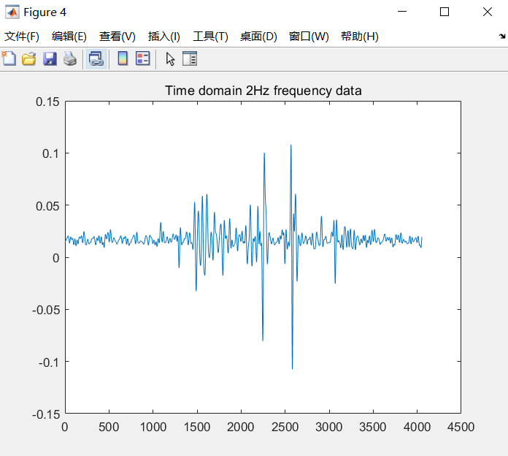

1. You could adjust the range of power spectrum’s frequency, power and samples in the property inspector.

